

**DESIGN PUBLIC HEARING WEBINAR PRESENTATION WEBINAR**

# JUNE 11, 2020

**FOR THE PROPOSED**

# Superstructure Replacement Project; Roaring Brook Road Over Roaring Brook,

**Project No. 608636**

**Bridge No. L-07-006**

**Roadway Project Management**

**IN THE TOWN OF LENOX, MASSACHUSETTS**

**COMMONWEALTH OF MASSACHUSETTS**

**MASSACHUSETTS DEPARTMENT OF TRANSPORTATION**

**HIGHWAY DIVISION**

**JONATHAN GULLIVER**

**HIGHWAY ADMINISTRATOR**

**PATRICIA A. LEAVENWORTH, P.E.**

**CHIEF ENGINEER**

**THE COMMONWEALTH OF MASSACHUSETTS**

**MASSACHUSETTS DEPARTMENT OF TRANSPORTATION – HIGHWAY DIVISION**

**NOTICE OF A PUBLIC HEARING WEBINAR**

**Project File No. 608636**

A Design Public Hearing Webinar will be published on the MassDOT website to present the design for the proposed Bridge Superstructure Replacement on Roaring Brook Road Over Roaring Brook project in **Lenox**, MA.

WHEN: **Thursday, June 11, 2020 @ 7:00PM**

PURPOSE: The purpose of this hearing webinar is to provide the public with the opportunity to become fully acquainted with the proposed Bridge Superstructure Replacement on Roaring Brook Road Over Roaring Brook project. All views and comments submitted in response to the webinar will be reviewed and considered to the maximum extent possible.

PROPOSAL: The proposed project consists of bridge superstructure replacement for the Roaring Brook Road Over Roaring Brook. The work will include the removal and replacement of the existing bridge superstructure; reuse and repair the existing substructure; and reconstruct the approach roadway. The Roaring Brook Road Traffic during the entire construction will be accommodated with single lane bi-directional service controlled by temporary traffic lights with the town police onsite during the construction workhours. The proposed bridge curb to curb width will be 25 feet 7 inches and tapered to meet the existing approach roadway. Bicycle and pedestrian accommodations are not included in this project.

A secure right-of-way is necessary for this project. Acquisitions in fee and permanent or temporary easements may be required. The **town** is responsible for acquiring all needed rights in private or public lands. MassDOT’s policy concerning land acquisitions will be presented in the webinar.

Written views received by MassDOT subsequent to the date of this notice and up to five (5) days prior to the date of the webinar, plans and a project handout will be made available on the MassDOT website listed below.

Written statements and other exhibits regarding the proposed undertaking are to be submitted to Patricia A. Leavenworth, P.E., Chief Engineer, MassDOT, 10 Park Plaza, Boston, MA 02116, Attention: **Roadway Project Management,** Project File No. **608636**. Mailed statements and exhibits intended for inclusion in the public hearing webinar transcript must be postmarked no later than ten (10) business days after the webinar is posted to the MassDOT website listed below. Project inquiries may be emailed to [dot.feedback.highway@state.ma.us](mailto:dot.feedback.highway@state.ma.us)

This location is accessible to people with disabilities. MassDOT provides reasonable accommodations and/or language assistance free of charge upon request (including but not limited to interpreters in American Sign Language and languages other than English, open or closed captioning for videos, assistive listening devices and alternate material formats, such as audio tapes, Braille and large print), as available.  For accommodation or language assistance, please contact MassDOT’s Chief Diversity and Civil Rights Officer by phone (857-368-8580), TTD/TTY (857-368-0603) or by email ([MassDOT.CivilRights@dot.state.ma.us](mailto:MassDOT.CivilRights@dot.state.ma.us)). Requests should be made as soon as possible prior to the meeting, and for more difficult to arrange services including sign-language, CART or language translation or interpretation, requests should be made at least ten (10) business days before the webinar.

Hearing webinar cancellation announcements will be posted on the internet at [**http://www.massdot.state.ma.us/Highway/**](http://www.massdot.state.ma.us/Highway/)

JONATHAN GULLIVER PATRICIA A. LEAVENWORTH, P.E.

HIGHWAY ADMINISTRATOR CHIEF ENGINEER



Dear Concerned Citizen:

The Massachusetts Department of Transportation (MassDOT) is committed to building and maintaining a transportation infrastructure that is both safe and efficient for all who use our roadways, bridges, bicycle facilities and pedestrian paths, while maintaining the integrity of the environment.

As part of the design process for this project, we are conducting this public hearing webinar to explain the proposed improvements, listen to your comments and answer any questions you may have. At the conclusion of the webinar, MassDOT will review all of your comments and, where feasible, incorporate them into the design of the project.

We recognize that road and bridge construction can create inconveniences for the public. MassDOT places a great deal of emphasis on minimizing the temporary disruptive effects of construction.

MassDOT encourages input from local communities and values your opinions. Please be assured that we will undertake no project without addressing the concerns of the community.

Sincerely,

Patricia A Leavenworth, P. E.

Chief Engineer

**WHAT IS A PUBLIC HEARING?**

**WHY A PUBLIC HEARING?**

To provide an assured method whereby the Commonwealth of Massachusetts can furnish to the public information concerning the State’s highway construction proposals, and to afford every interested resident of the area an opportunity to be heard on any proposed project. At the same time, the hearings afford the Commonwealth an additional opportunity to receive information from local sources which would be of value to the State in making its final decisions to what design should be advanced for development.

**WHY NOT A VOTE ON HIGHWAY PLANS?**

The hearings are not intended to be a popular referendum for the purpose of determining the nature of a proposed improvement by a majority of those present. They do not relieve the duly constituted officials of a State highway department of the necessity for making decisions in State highway matters for which they are charged with full responsibility.

**WHAT DOES A PUBLIC HEARING ACCOMPLISH?**

It is designed to ensure the opportunity for, or the availability of, a forum to provide factual information which is pertinent to the determination of the final alternative considered by the state to best serve the public interest, and on which improvement projects are proposed to be undertaken.

It is important that the people of the area express their views in regard to the proposal being presented, so that views can be properly recorded in the minutes of the meeting. These minutes will be carefully studied and taken into consideration in the determination of the final design.

**RIGHT OF WAY CONCERNS**

Your Municipality is responsible for securing the right of way for this project. If your property, or a portion of it, must be acquired by the Municipality for highway purposes in the interest of all people of the Commonwealth, your rights are fully protected under the law. Briefly, here are some of the answers to questions you might ask.

1. REASON FOR PROJECT

The completion of this project will serve local needs. The proposed enhancement will also be in the interest of others in the greater community, and provide for the public good.

1. WHO CONTACTS ME?

Representatives of the municipality have already contacted or will contact you. They will explain the procedures used in acquiring any necessary rights in land.

3. WHAT ABOUT DONATIONS? WHAT IS A RIGHT OF ENTRY?

Town officials will often seek donations, of parcels, where permanent rights are required. This procedure will minimize the acquisition cost for your community.

A Right of Entry is a document that is signed by the owner. It allows the Contractor to perform certain types of work on the owner’s land. The work is usually minor in nature and frequently consists of loaming/seeding behind sidewalks, new driveway apron work, grading/sloping, and wetland protection, etc. The rights granted are temporary in nature.

1. WHAT IS A FAIR PRICE FOR THE ACQUIRED PARCELS?

In the event that donations are not considered, or completed, every effort will be made to ensure that an equitable value is awarded. Municipal and/or outside appraisers will complete an appraisal. Consideration is given to the type of rights needed, whether in fee, permanent or temporary easements. The appraisal will be the basis for arriving at a fair price (for damages that result).

1. MUST I ACCEPT THE MUNICIPALITY OFFER?

No, if the owner feels that the offer is not fair the owner may petition the courts. This action does not stop or delay the acquisition. The action must occur within 3 years. The owner(s) may be paid pro tanto (for the time being). The pro tanto payment will not prejudice the court’s final decision.

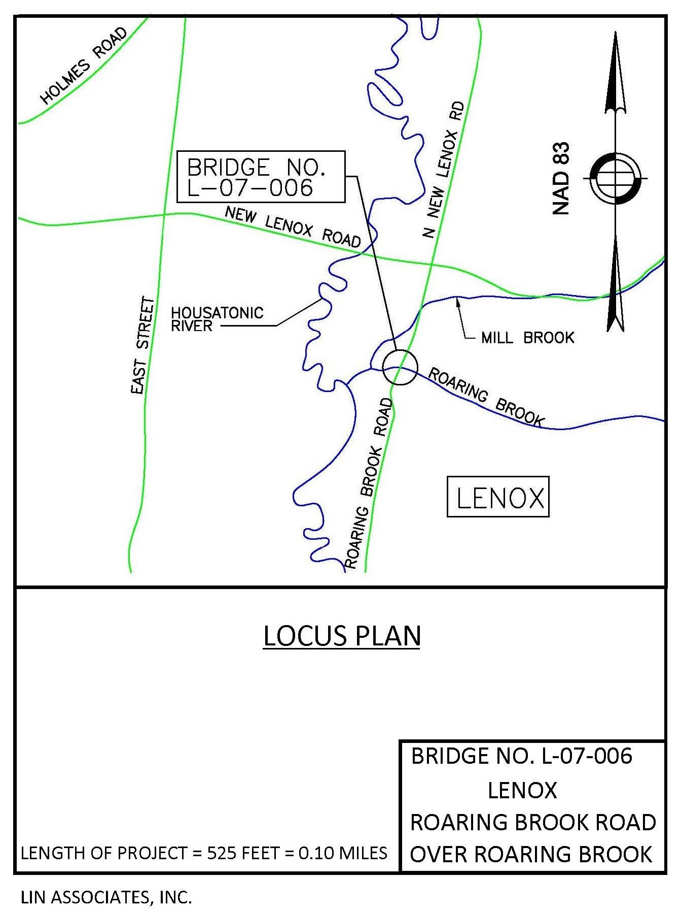

**MASSACHUSETTS DEPARTMENT OF TRANSPORTATION**

**HIGHWAY DIVISION**

**PUBLIC HEARING**

**BRIDGE RECONSTRUCTION – BRIDGE NO. L-07-006**

**PROJECT FILE NO. 608636**

**IN THE TOWN LENOX MASSACHUSETTS**

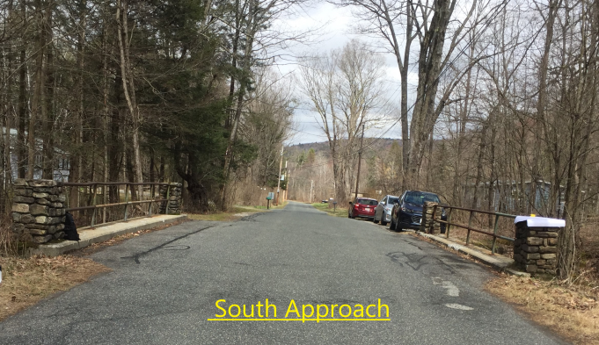

**Project Location and Limits:**

The project is located in the Town of Lenox and includes the Roaring Brook Road Bridge over Roaring Brook as MassDOT Bridge No. L-07-006 and the roadway approach to the bridge. The attached locus map shows the location of the project. The length of the project is 525 feet between the limits of work.

**Purpose and Need:**

The purpose of this project is to replace the structurally deficient bridge over Roaring Brook with a new bridge in the same location. The Massachusetts Department of Transportation (MassDOT) proposes bridge safety improvements with the replacement of the superstructure by maintaining the existing bridge width and with minimal roadway approach work.

**Existing Conditions:**

# Roadway Characteristics -

* Roaring Brook Road is paved on the approaches to the bridge, carries two travel lanes, no shoulders and no sidewalks. The pavement width is approximately 16-18 feet and appears to be in good condition. There are no guardrails on the approaches to the bridge.
* A utility line on the easterly side of Roaring Brook Road passes overhead just to the outside edge of the bridge, with a pole located closely adjacent to the southeasterly end of the bridge. Other than the electric power, telephone and cable supported by the utility pole line, no other utilities are in the roadway or carried by the bridge.

# Bridge Characteristics -

* The bridge, constructed in 1939, is a 35 feet - 4 inch long single span steel beam bridge on a tangent alignment supported on unreinforced concrete gravity type abutments with wingwalls all on spread footings.
* The bridge is carrying two 12-foot travel lanes with 21-inch wide parapets on both sides supporting pipe railings for a total out-to-out width of 27 feet - 6 inches.
* The existing bridge railings consist of steel tube posts and hand rails connected to stone masonry end posts on each side.
* Six W24 x 74 steel stringers support a 6½-inch concrete deck that is crowned in the middle with 3/16-inch cross slope. The surface of the deck is paved with bituminous concrete.
* All of the existing steel beams have moderate to severe corrosion throughout, with section loss in certain areas.
* According to the structure inventory and appraisal form, on January 1, 2016 the bridge was posted as follows for below the statutory loadings:

2 AXLE (TYPE H Truck, 20 Tons) 8 Tons

3 AXLE (TYPE 3 Truck, 25 Tons) 10 Tons

5 AXLE (TYPE 3S2 Truck, 36 Tons) 15 Tons

* The existing substructure, including concrete abutments and wingwalls, has been inspected, material tested, analyzed, and determined to be in good condition for the reuse. Concrete repairs will be required for localized deterioration including Northeast wingwall.

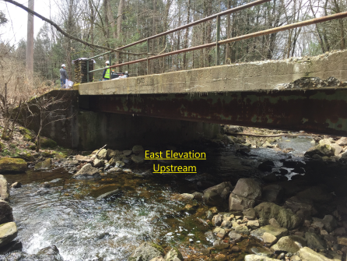

**Utilities Within Bridge Site** -

* No existing electrical, cable, gas, water, or sewer located on the bridge
* No existing utilities buried in the vicinity of the bridge
* Electrical and telephone on overhead wires along the east side of the bridge
* Temporary relocation of overhead wires

**Hydraulics at Bridge Site** -

* Evidence of Scour and Erosion: None Documented in NBIS Database
* Potential for Scour: Existing structure is hydraulically adequate to safely convey the 10-year design storm as concluded in Hydraulic Study Report

**Environmental -**

* Roaring Brook is a unique stream in that it originates in October Mountain State Forest and it travels through only undeveloped forest. There are small width wetlands contiguous with and on both sides of Roaring Brook.
* A pathway owned by the Department of Conservation & Recreation (DCR) is located on the northeast of the bridge. Any construction easement on the DCR property would require coordination with the agency to have Section 4(f) filed.

**Proposed Design:**

**Modified Geometry**

No significant geometric changes are proposed to either the horizontal alignment or the profile. No changes in bridge width or approach roadway width are proposed.

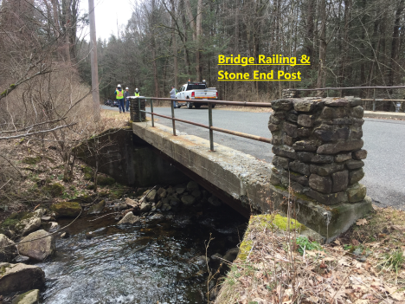

**Safety Enhancements -**

The following safety improvements are included in the project:

* Replacement of the deteriorated bridge superstructure.
* Installation of a double yellow centerline.
* Construction of new bridge railing in conformance with current standards.
* Installation of guardrail on the roadway approach tapered to the bridge and attached to the proposed bridge railing.

**Bicycle and Pedestrian Accommodation -**

* Roaring Brook Road is a municipal unstriped local road having no posted speed limit. Neither sidewalks for pedestrian nor shoulders for bicycle exist on the existing roadway; therefore, none are proposed for this project.
* Traffic volume is recorded as very low (ADT 100). The proposed project section follows Case 5: Shared Accommodation for All Users as described in MassDOT’s 2006 Project Development and Design Guide.
* The low volume of pedestrians and cyclists expected to use the facility will share the road section as is currently the practice at the site. Based on the conditions at the site and the two 12-foot travel lane section proposed, a design exception is not required.

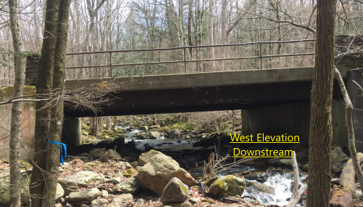

**Hydraulics -**

* Proposed bridge is designed to have the beam low chord elevation to match the existing
* Existing abutments are to be reused to keep the same hydraulic opening

**Environmental -**

* Categorical Exclusion (CE) Checklist with attachments were submitted for the 25% design
* The project does not meet any Massachusetts Environmental Policy Act (MEPA) Review Thresholds for a mandatory Environmental Impact Report (EIR) or an Environmental Notification Form (ENF).
* The proposed project will not impact the Massachusetts State Wetland Resource Areas of Bordering Vegetated Wetland (BVW), Bank, or Land under Water Bodies/Waterways (LUWW). Therefore, the proposed work is not subject to permitting under Sections 401 or 404 of the Clean Water Act.
* The project is a footprint bridge project and is exempt from the requirements of the Massachusetts Wetlands Protection Act (MWPA)
* No impacts to the Brook, wetland replacement, and landscape improvements

**Traffic Management -**

* Staged Construction: 2 stages required with police detail on daytime construction and variable message sign at nighttime
* Number of Lanes To Be Maintained: One lane with alternate two way traffic in each stage
* Brief roadway shutdowns are anticipated during bridge demolition/construction in stages.

**Right of Way -**

* The current design plans indicate that there are 4 permanent easements, and 5 temporary easements required.
* The temporary utility relocation easement will be required on the DCR property
* The property owners impacted by this project will be contacted by municipal officials. They will present the proposed impacts to each owner and discuss the methods with which they may acquire the needed rights for the project.

**Utility Relocation -**

* Utility field meeting was conducted with National Grid for utility relocation including tree trimming
* An easement line for trimming limits on the DCR parcel will be shown 20' right of the pole centerline.
* Any additional trimming beyond that point would have to be approved by DCR.
* ROW plan will include the clearing limit offset 10' and the trimming limit offset 20' from the pole.
* MassDOT contractor will do the clearing to the 10' line and any trimming required by National Grid.

**Project Cost -**

The estimated cost of the proposed construction of the Roaring Brook Road Bridge over Roaring Brook is approximately $1,500,000.

**Construction Duration -**

With a mid-year Notice to Proceed, construction would span over the winter with potential snow shutdown. Twelve months construction duration is estimated as per the preliminary Construction Time Determination. The estimated length of time required for one lane, two-way traffic is nine months.

**Project Status -**

The plans on display tonight are at the 25% Design Stage. Comments received this evening will be considered in determining the final design. The design of this project is anticipated to be completed and advertised by May 2021.

**LENOX - DESIGN PUBLIC HEARING**

Frequently Asked Questions/Answers:

Q1: Any consideration given to close the bridge with traffic detour to shorten the construction duration?

A1: First, keeping one lane open is to allow emergency vehicle or fire truck a quick access to respond to any incident in the project area.

Secondly, the 10’ wide dirt road on the southern end of Roaring Brook Road would be impassable for emergency vehicle or fire truck as 10’-6” is a minimum roadway width.

Q2: Any consideration given to replicate the existing pipe railing and stone end post?

A2: Pipe railing and stone end post are not in compliance with the current safety standards regarding crashworthiness. The proposed S3-TL4 steel bridge railing is the MassDOT standard.

Q3: Any consideration given to provide bicycle and pedestrian accommodation?

A3: With the proposed bridge width matching the existing at 27’-6”, there isn’t enough room to provide a shoulder for bike lane or sidewalk for pedestrian with the travel lane at12’-0” in each direction.

Q4: Any consideration given to reduce a number of trees being removed as a result of utility relocation?

A4: In the attempt by D1 DUCE to reduce tree removal due to utility relocation, utility field coordination meeting has been conducted with National Grid and determined the 25% design is adequate to have 12 mature trees to be removed. It also established the clearing limit offset 10’ and trimming limit offset 20’ from the pole. Force account estimates for National Grid was submitted. Two other FA estimates have not been submitted yet, including Charter Communication for the relocation of the overhead cable line and Verizon for the relocation of their telephone lines and for the removal of the existing poles.

Q5: How many permanent and temporary easements are proposed for this project?

A5: Per 25% ROW Plan, there are 4 permanent easements and 5 temporary easements proposed for this project. Permanent easement is for embankment slope while temporary easement is for grading, erosion control, clearing & grubbing.

Q6: Any environmental impact or permits required for this project?

A6: Since this is a MassDOT footprint bridge and the substructure to be retained such that all permitting requirements have been waived.

Q7: The existing bridge has weight limits posted. Will the proposed bridge have the same weight limit?

A7: This is the reason for replacing the bridge as the existing bridge has substandard load carrying capacity as follow: 8 tons for 20 tons type H truck, 10 tons for 25 tons Type 3 truck, and 15 tons for 36 tons Type 3S2 truck. The proposed bridge will meet statutory loadings for all 3 types of trucks and emergency vehicle/fire truck as well.

THE COMMONWEALTH OF MASSACHUSETTS

MASSACHUSETTS DEPARTMENT OF TRANSPORTATION

HIGHWAY DIVISION

FEDERAL AID PROJECT

Lenox, MA

Bridge Superstructure Replacement Project

# Roaring Brook Road Over Roaring Brook

Project File No. 608636

This sheet is provided for your comments. Your input is solicited and appreciated. Please mail this sheet with any additional comments to:

Patricia A. Leavenworth, P.E., Chief Engineer

MassDOT – Highway Division

10 Park Plaza, Boston, MA 02116-3973

Attn: Roadway Project Management Section

The final date for receipt of written statements and exhibits for inclusion into the official hearing transcript will be ten (10) days after the Public Hearing Webinar.

**PLEASE TYPE OR PRINT LEGIBLY.**

__________________________________________________________________________________________________________________________________________________________________________________________________________________________________________________________________________________________________________________________________________________________________________________________________________________________________________________________________________________________________________________________________________________________________

______________________________________________________________________________

Name: _________________________________ Title:_______________________________

Organization: __________________________________________________________________Address:____________________________________________________________________________________________________________________________________________________

Please Fold and Tape



Please Place

Appropriate

Postage Here

________________________

________________________

________________________

Patricia A. Leavenworth, P.E.

Chief Engineer

MassDOT – Highway Division

10 Park Plaza

Boston, MA 02116-3973

RE: Public Hearing Webinar

Bridge Superstructure Replacement Project - Roaring Brook Road Over Roaring Brook

## Lenox

Project File No. 608636

Roadway Project Management Section

