Lenox Finance Committee Meeting
Date: April 29, 2020
Members Present: Elliott Morss (EM), Kristine Cass (KC), Michael Feder (MF), David Neubert (DN) Vytas Barsaukas (VB)
Guests: Clarence Fanto, Chris Ketchen (CK)
Absent: Mark McKenna, Joe Nejaime, Joan Bruno, Scott Pignatelli
ZOOM Meeting called to order at 5:00 PM.
Note: The following are the minutes interspersed with my comments (EM).

Minutes

The meeting started with MF asking CK a series of questions about CK’s Revised FY 2021 Budgeted Expenditure Recommendations and Revenue Assumptions. In addition to normal budgeting entries, the questions focused on cash based income and expenses.

EM Comment: A budget normally covers income and expenditures: how much is the Town taking in and how much is it spending. That is not true when it comes to the entries in CK’s budget. The cut in the Vincent Rule funds do not mean an expenditure cut. Rather, it constitutes a fund set-aside. Putting more or less money in OPEB is a matter of portfolio management and no outlay. The appropriation for a fire truck does not represent Town expenditure.

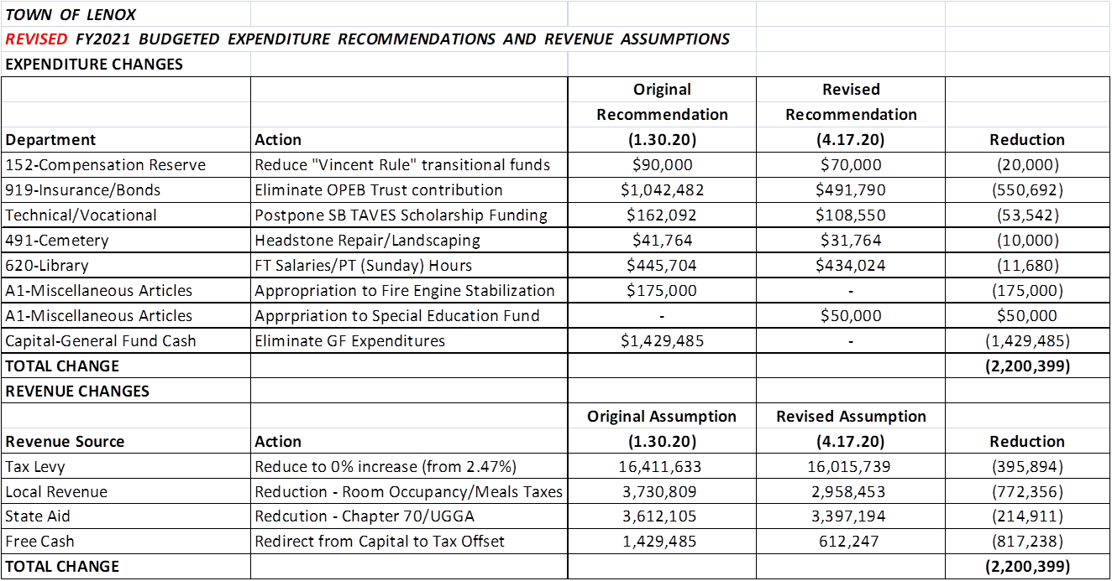

It was also interesting to hear CK’s response to my question about property tax revenues. There are two things that drive tax revenue changes: a tax rate change and changes in the assessed values: Revenues = Assessed Values X Tax Rate. I asked CK what will happen to assessed values with the downturn. I did not pick up exactly what he said, but part of it was that it did not matter what happened to assessed values.

Another EM Comment
Every year, we get a large “book” full of details down to the dollar on planned outlays. We get half a page on revenues and one page on planned capital outlays. In the future, I think we should ask CK for more detail on revenues.

Minutes (cont.)

Comments by VB and MF led to a discussion of concerns over the School Budget and whether the School Committee is doing enough to cut outlays in light of closings. It was agreed that DN and MF, the two FinCom members that have worked with the schools during this budget year, will meet with the School Committee and express our concerns.

This was followed by a discussion of Town businesses and whether there was anything more the Town government could do to help them. EM mentioned before the pandemic, we had approved an increase in advertising/economic development support from $90,000 to $109,400. He wondered whether the allocation of these monies had changed. Following our meeting, MF contacted Jenn Nacht, the Chamber CEO to ask where we stand with advertising and plans going forward. Jenn said she had suspended the initial program and is the process of working with the agency to refocus it towards drawing people to Lenox for our attractions other than the cultural. She expects to start the outreach as soon as things ease, especially access to hotels and Inns. She is also working on activities in town that will be manageable under restrictions and act as a draw. She mentioned, in passing, that the SBA and employee support loans were helping a bit and not for everyone. The biggest issue the chamber members are facing seems to be rent demands from their landlords.

DN launched a discussion of what it likely to happen from an economic standpoint this summer in The Berkshires. He said he was quite optimistic, that from people he had talked with, many people who might otherwise take extended trips will now remain close to home. And that could mean more visitors from NYC and other neighboring town/cities.

Another EM Comment: If this is so, it is a shame that so many of our cultural entities have cancelled their seasons. Maybe they can open up if things look promising….

MF said what DN offered was not a consensus view. MF expressed concern over the reality being worse than expected.

Minutes (cont.)

KC asked Chris where would he look to make cuts in the event that he had to cut the budget further. Chris responded that that was a very hard question and it would require all budgets to be examined again.

EM was concerned that state-imposed and other restriction would impede our ability to start up again, that we are very different than Boston. For example, he noted that the tennis courts at the Community Center were closed. CK mentioned that the Governor had just created a Startup Committee with nobody on it from west of Easthampton.

Another EM Comment:

Somebody should discuss this with Smitty….

Meeting adjourned at 5:45 PM.

Respectively Submitted,
Elliott Morss, Acting Secretary

